1. Open the firmware download tool

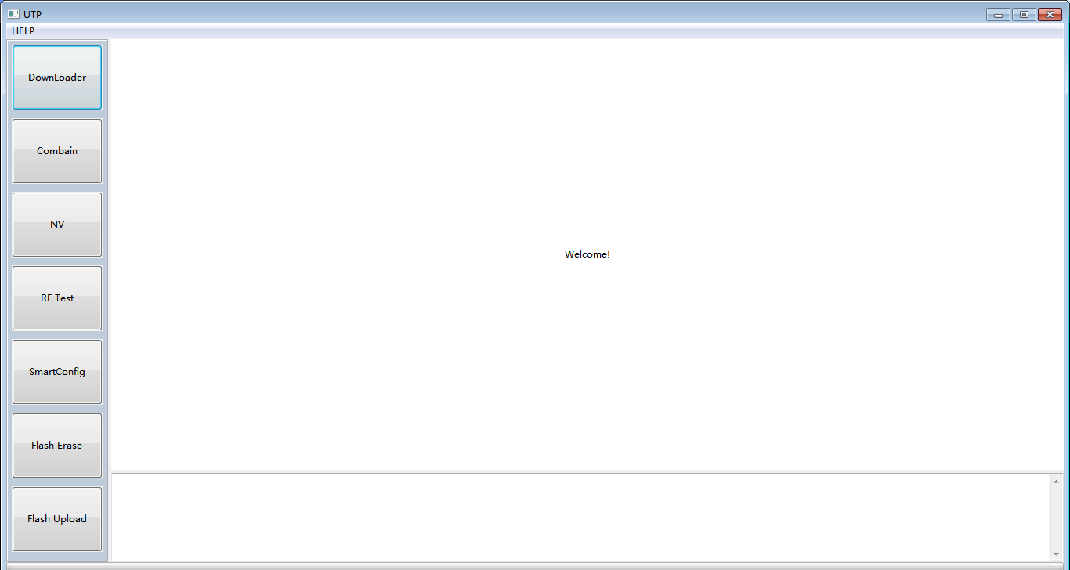

1. Short-circuit the reset button first (connect RST to ground)

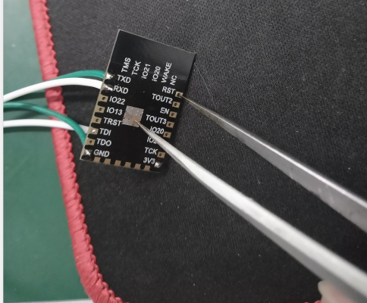

4. Then click Download. (Set in advance, baud rate 115200)

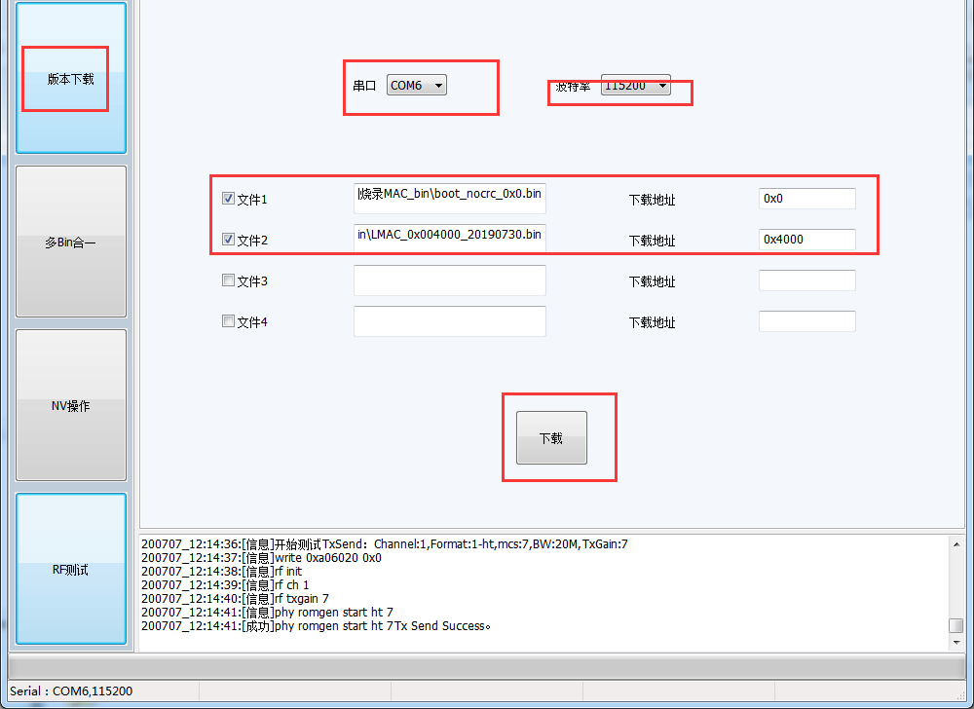

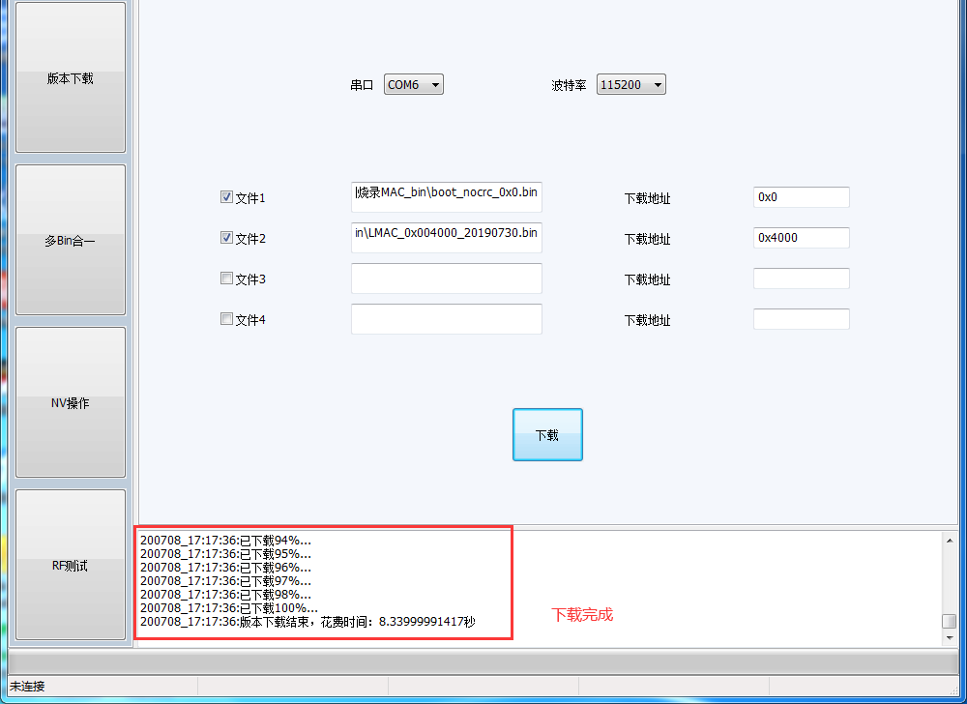

The download is complete.